***MATH GAME***

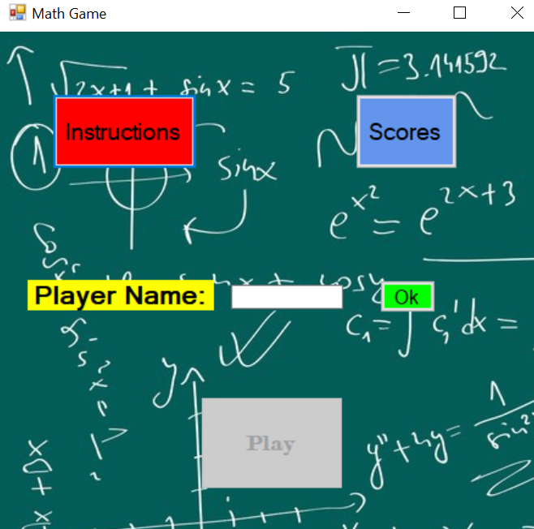

***Table of Contents***

Page 2 - Step 1 (Defining the Problem)

Page 5 - Step 2 - The Word Documents for Step #2 (Analysis and Design)

Page 7 - Sites used as reference

Page 8 - Final Work Log

ICS3U – FINAL PROJECT  
STEP 1 – DEFINING THE PROBLEM

***Type of Application*** (i.e. game, text editor, trivia, music app, other)

Math questions game.

# ***Detailed Application Description*** (ie. storyline, how to play, scoring, similarities to other programs)

User answers ten questions inside textbox and after the completion of each level with a perfect score the user moves on to the next level. First it will be random addition questions, then subtraction, then multiplication, then division, for the final level the user will be given a mix of difficult problems. The user must answer all questions and leave none of them blank to move on to the next level. The user will only know if they got everything right at the end of the level when they click done or when the timer runs out. The user will get two minutes to complete all the questions on each level.

***Programming Knowledge Required*** (i.e. variables, loops, procedures, selection etc…)

Explanation: List the programming concept and explain how you plan to use it in your application (*i.e. Sorts – The program will read previous scores from a file and sort them high to low on a secondary form.*)

Sorts- the program will read the score of the player and sort it from high to low on a secondary form for them to see how they rank up.

Random numbers- this operation will be used in order to generate random numbers for each level.

Counter- used to add the users score in order to add to the leaderboard

Texts file Reader – read scores from the file to get the scores sorted and displayed in the leaderboard

Timer – gives the user a time limit of one minute to answer the questions.

Animations – to display cool moving shapes in the background of the form

Sounds- will be used to give some background noise for user in order to pressure them. (like Kahoot)

Procedures – to hold randomly generated questions in order to call them up when each level is changed

Array – to hold the user names and score for the output on to the leaderboard

Loops - used to run through all the scores and reorder them at the end of each game in order to display them on the leaderboard screen

Function – Used to return if the user passed the level with a perfect score or if they got questions wrong. Will display how many they got wrong

Variables- used to hold things like final score, number of questions, type of questions with the right amount of digits. (Project will include questions with more than one digit).

ICS3U – FINAL PROJECT  
STEP 2 – ANALYSIS AND DESIGN

**APPLICATION SUB PROGRAMS**

1. List the various subprograms that you will create in your project. (Event Procedures, General sub procedures, and Functions)

* Overall event procedure to stop music on home screen when any button is clicked.
* Sub procedure that determines if every answer is right. Enables button to move onto the next level.
* Sub procedure that beings user back to home screen if the score is not perfect
* Event procedure to have a form load with a 3,2,1 counter to signal the game is starting.
* Sub procedure to add the amount of right answers to the final score
* Sub procedure to add the score to the file
* Sub procedure to read and add the scores to the leader boards.
* Sub procedure to randomize the questions for each level
* Function to go through every questions and determine which ones are wrong and right.

1. Outline the purpose of each of the functions & procedures you mentioned from the previous point.

* Question 2 answered above.

1. Remember that you are NOT writing computer code during this phase.

**DEVELOPMENT PLAN**

Create a basic daily calendar outline and the functions and procedures will be created and a time-line for completion. List when you would like particular portions of your application complete.

*SAMPLE*

*June 3 – complete part 2*

*June 4 – hand in completed part 2*

*June 5 – start designing the main interface and learn how to make a countdown timer*

*June 6 – Make the high scores form and the instructions form. Add music to the main form*

*June 7 – On level one of the form start plotting where things will go, repeat for all 5 levels. Eg. (textbox for answers and labels for randomized questions*

*June 10 – make a sub procedure that will randomize the questions for level one.*

*June 11 – make sub procedure for randomizing questions for lvl 2, lvl 3, lvl 4, lvl 5*

*June 12- Make a function that check the answers and determines if the user gets them all right.*

*June 13 – test project to see if all components are working properly. Include a text file and a read and output scores to the leaderboard page.*

*June 14- final debugging. Make interface user friendly and make it look nice.*

**PROBLEM SOLVING TOOLS**

1. Complete a minimum of 2 of the following 3 problem solving tools.
   1. Create an IPO chart for one of your function or procedures (general or event)
   2. Create a Flowchart for one of your function or procedures (general or event).
   3. Outline an Algorithm for one of your function or procedures (general or event).

b. Flowchart attached (on Microsoft Publisher)

c. Algorithm for adding the number of right answers to the final score if the user gets all the answers right then they get a score of ten added on. If the user gets anything wrong on any of the levels the number of right gets added on to their final score and the game ends.

a. User will input all of their answers under the time limit.

b. User will click check answers once done.

c. Computer will compare values of the answer given by user and what the answer should be. Repeated for all ten questions.

d. For every right answer the counter is added to by one point.

e. The computer will display the final score on the counter.

**Sites Used as Reference**

**Copy and paste the URL for all websites outside of the course website that you used in the creation of your final project. If you submit work that you do NOT give credit to the creator, this can result in loss of marks or a zero on your final project.**

1. <https://www.youtube.com/watch?v=jOeBgDxKFbk> (Learned how to actually show a timer on the screen countdown to 0)
2. <https://www.youtube.com/watch?v=PJwmqHDWt74> (Used this to learn how to split apart minutes, seconds, milliseconds on the timer)
3. <https://www.daniweb.com/programming/software-development/threads/257660/moving-labels-picture-boxes> (learned how to move picture box up and down bouncing off the form sides) (used for the starting form)
4. <https://stackoverflow.com/questions/18971322/vb2010-how-to-tell-if-a-number-is-a-whole-integer> (learned how to determine if the inputted number is an integer or not)

ICS3U - Culminating Activity – Work Log

Work log should be completed **daily** outlining your accomplishments for the day and what you plan on working on the next day. This log will be checked randomly throughout the process to verify it is being completed along the way.

|  |  |
| --- | --- |
| **Monday – May 27, 2019** | Completed: Started brain storming ideas, thought about the game Tetris, snake and flappy bird. Asked myself if these projects were doable in the in the time given.  Tomorrow: Will continue to brainstorm and think of ways to actually implement the idea |
| **Tuesday – May 28, 2019** | Completed: Started asking myself how to implement the idea of snake and Tetris. I realized that flappy bird would be too hard to do as it would have to involve gravity. Learned how to use the arrow keys on the keyboard to move a picture box. This could potentially be used to move the snake or move the blocks in Tetris  Tomorrow: Will try to see how to make a do collisions on visual basics |
| **Wednesday – May 29, 2019** | Completed: Learned how to do collisions and luckily we got to learn how to hit object with bullets on the sample program taken up in class. Learned how to make a multiform for more applications.  Tomorrow: Will try to think of a different project that is less complicated. Will probably work on a trivia style game which would be easier in the time frame given. |
| **Thursday – May 30, 2019** | Completed: Thought of another idea. Will create a math questions game with basic questions from all operators (adding, subtracting, etc.). Started filling out the STEP 1 for the project. Thought about what components will be used to accomplish the program.  Tomorrow: Will think about the interface of the game and also complete the Step 1 |
| **Friday – May 31, 2019** | Completed: Thought about how to implement the various computer programming components and what the interface will look like. Completed the Step 1 of the project.  Tomorrow: Will start the main interface/ starting page.  **STEP 1 DUE**  **Work Log 1 Due** |
| **Saturday – June 1, 2019** | Did nothing on the weekend. |
|  |  |
| **Monday – June 3, 2019** | Completed: Started doing the Step 2 of the process. Did not start the main interface because I had not finished the Step 2. For step 2 I finished the first question  Tomorrow: Will try to finish the rest of Step 2. |
| **Tuesday – June 4, 2019** | Completed: Finished rest of Step 2. Made flowchart and completed an algorithm for one of the functions. Handed in the document on D2L.  Tomorrow: Will start the interface for the project. |
| **Wednesday – June 5, 2019** | Completed: Started making the interface of the project. Made multiple forms. One form for the main screen. One for the instructions and another for the high scores for the game. Added some music to the main page.  Tomorrow: Will start the interface for level 1.  **STEP 2 DUE** |
| **Thursday – June 6, 2019** | Completed: Started the interface for level 1. Added labels and textboxes so that the user could input answers. There will be 5 questions on each level. Randomized the questions on the level 1 and made a score label so the user can get their score. Added a timer (Two minutes) for the level.  DECIDED THAT I WILL ONLY HAVE FOUR LEVELS!  Tomorrow: Will complete the second level. This will include subtraction. |
| **Friday – June 7, 2019** | Completed: Today I started the interface for level 2, level 3, level 4. Level two will be subtraction, level three will be multiplication, and level four will be division. Completed programming all level 2 and 3. Started the randomizing process for left side of division level. Tried to figure out how to keep things simple for division and also randomize the questions in order to allow for whole number answers.  Tomorrow: Will try to finish the division level so that the user can input whole numbers.  **Work Log 2 Due** |
| **Saturday – June 8, 2019** |  |
| **Sunday – June 9, 2019** |  |
| **Monday – June 10, 2019** | Completed: Today I randomized the division questions so that the answers will be whole numbers making it a bit easier for the user. Also made a function to have pictures bouncing on the main page to make it look good.  Tomorrow: Will try to read and write scores to a fill in order to display on the leaderboard |
| **Tuesday – June 11, 2019** | Completed: Today I had an issue with the buttons not working as they did not open any of the other forms. This was because the events were not handling any clicks so it was not working when I clicked the buttons. Then I tried to figure out how to write score and user name to the file.  Tomorrow: Will try to read and write to the leaderboard for the game |
| **Wednesday – June 12, 2019** | Completed: Today I added more picture boxes to the main start form. Finally had the leaderboard working. Name and score were written to the listboxes for the user to view the high scores.  Added picture boxes for level one to show user which questions they got wrong and which ones they got write.  Tomorrow: Will try to make the picture boxes move in different ways to have them bounce off the walls making it look cool. |
| **Thursday – June 13, 2019** | Completed: Made some quick fixes to the timer of the game making it run so that it take a total of two minutes. Then I worked on the documentation of the project as I was all most done  Tomorrow: I will fix the picture boxes bouncing so that all of them work evenly. If this doesn’t work I will draw different shapes to bounce around. |
| **Friday – June 14, 2019** | Completed: I had an error with my picture boxes as they were deleted, and the program kept crashing because there weren’t any images. Then I worked on documenting my project and I made some cosmetic changes such as adding a background. I also added picture boxes to all the levels to inform the user which questions they got wrong.  Tomorrow: I will complete the project, make any final adjustments and then hand it in. |
| **Saturday – January 15, 2018** | Completed : finished the table of contents and handed in the project on D2L |
| **Sunday – January 16, 2018** | **- PROJECT DUE BY END OF DAY**  **- FINAL WORK LOG DUE** |